**Setup Lab**

To setup a lab using GENI’s Infrastructure, we will need to have a user account setup and join the project. The project name will be provided by the instructor. In the following document, we use the project name as “ExampleProject” as an example. For instructions on setting up a user account or joining a project, see the Setup-User tutorial.

Every lab used on GENI will be apart of a specific project, and each project can be made up of multiple different labs. Each student will have to set up their own lab on GENI. Instead of creating new instances for each students lab, we will be deploying a clone of a preconfigured lab. In GENI these clones are referred to as “Slices”.

This procedure walks you through the steps take to set up the lab environment. The details can be different for different labs. Perform the following steps to set up the lab environment.

1. **Create a New Slice**

Login to portal.geni.net with your username and credentials.

Under the Slices tab, click the + New Slice button.

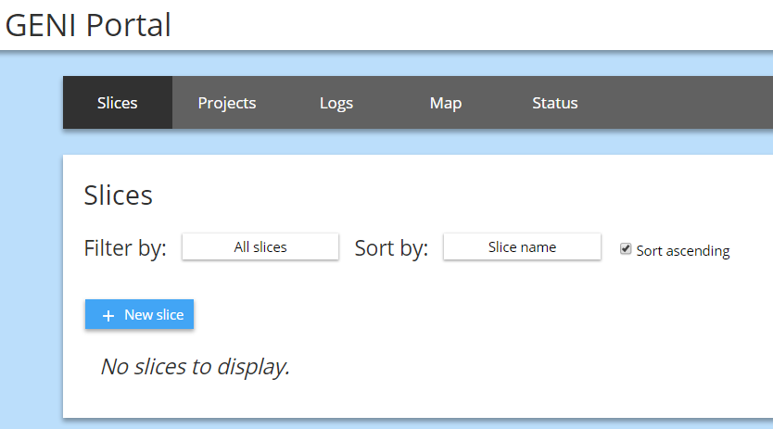

Make sure the correct Project is selected. Input an intuitive Slice Name that will differentiate your slice from other student’s slices.

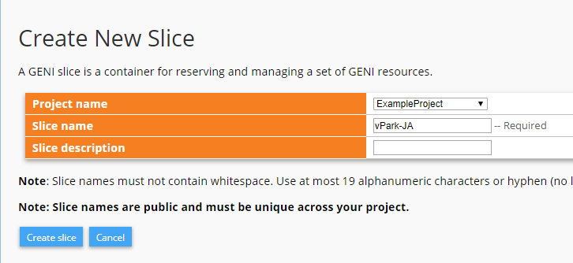

Click the button “Create slide”.

**2. Add resources**

On the next page, click the button located at the top of the slice.

This page lets users to reserve resources (machines) to be used in their lab environment.

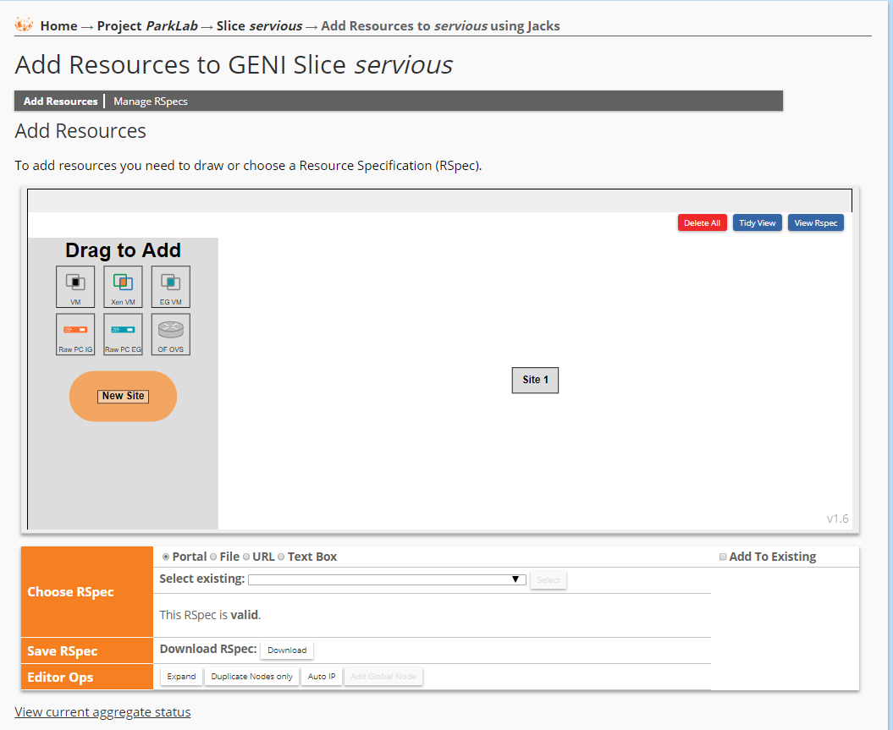

From this page, we will configure our whole lab environment.

**3. Apply the RSpec file**

At the bottom we can specify the lab configuration file achieve the correct network topology. These config files are called RSpec in the GENI Infrastructure. For each lab, there should be a lab specific RSpec file. You need to find the RSpec file in the specific lab instruction. This should be provided to the student, or be accessible to the student before they can continue.

**NOTE: The RSpec file will be provided on each lab instructions. Please refer to the lab documents to choose specific Rspec file.**

For Example: The following RSpec file can be used to create a single GENI virtual machine, that preinstalled VNC server, WebGoat, Firefox, etc.

<https://raw.githubusercontent.com/DrVoyager/vPark/master/rspec/vPark-snapshot.rspec>

**Note: All the following screenshots are based on the above RSpec file. You might see a little bit different based on your RSpec file specified on the lab document. Even though the screenshots are different, all the steps will be same as the following instructions.**

Usually, you can click the radio button URL and paste the URL of the RSpec file and click Select button.

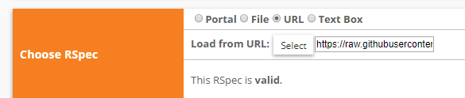

Once configured, you will see a visual of the network topology located near the middle of the screen.

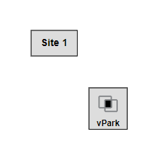

**4. Select a site.**

Then we must select a site that will host our lab. These sites are real organizations that help distribute GENI’s infrastructure. Click the Site 1 button located in the middle of the screen, to bring up a directory of Sites on the left side of the screen.

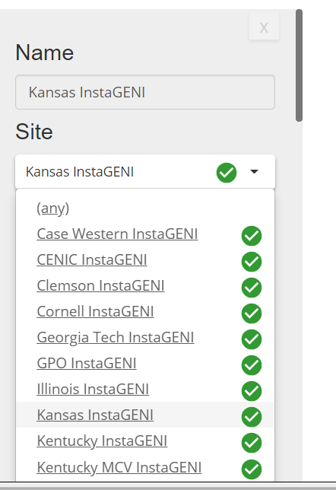

For optimum performance, we will want to choose a site specified by the instructor. For example, if you are using the RSpec file provided above, choosing UMKC InstaGENI will give you the fastest vm booting time (about 10-15 minutes).

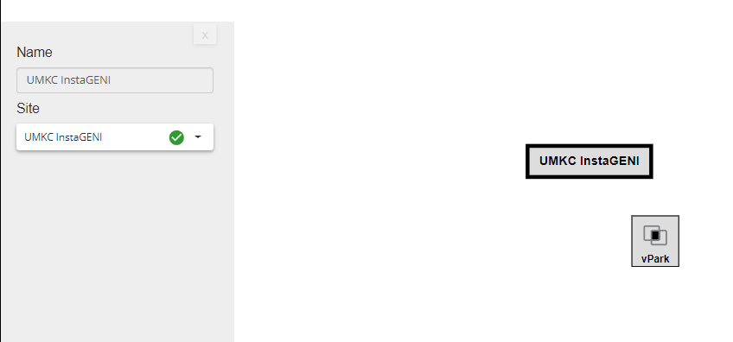

**5. Reserve resources.**

When you have selected a site, click the “Reserve Resources” button at the bottom of the webpage.

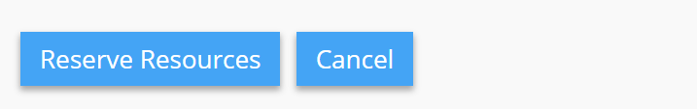

It will take several minutes to boot up all the virtual machines needed in the lab. When all of the machines are fully powered on and booted into, the color of the topology will change from grey to green.

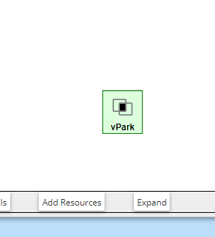

**NOTE:** Sometimes, the site you selected in step 4 does not have adequate resources to set up the lab environment. You will see a failure message. In this case, you need to go back to step 4 and select a different site. Since sometimes the deployment may fail. It is strongly recommended to leave enough time to set up your lab environment. For face-to-face student, it is usually required to set up your lab environment before coming to the class for the lab.

During the booting up procedure, you will see the resource information on the web page, like below:

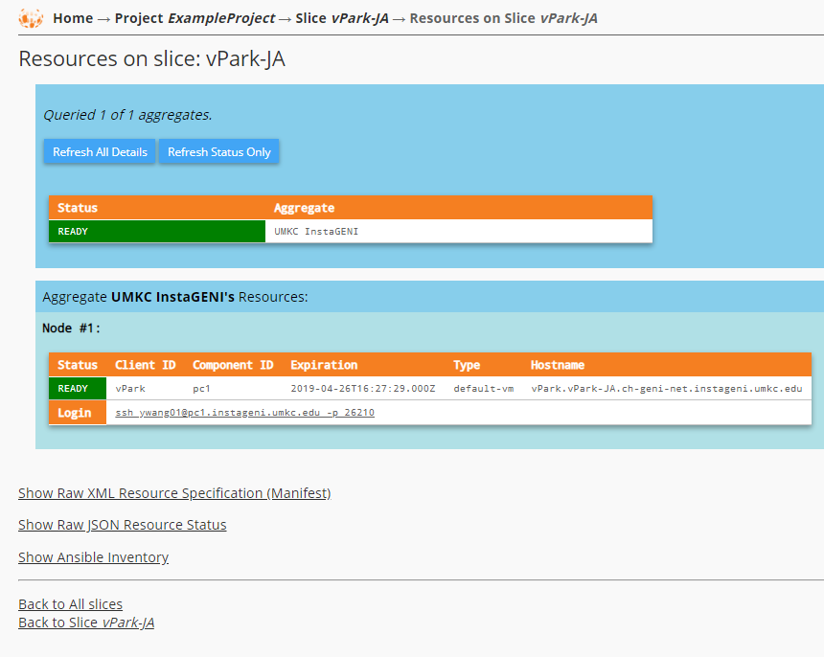

Once the status becomes “READY”, means the VM is ready for use.

**6. Log on the virtual machines in the lab environment**

When the lab environment is successfully set up. You will see the web page as follows:

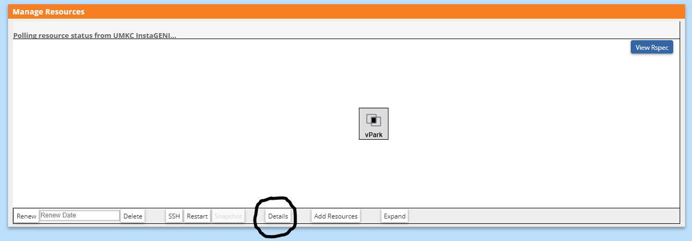

Clicking the Details button at the bottom, will display a list of details about each machine in this Lab’s network topology.

Below is a sample of the Details display for one single machine (node). Notice the client id is displaying *victim*, which is the name of one of the machines in the Lab.



Next to login, we see the ssh commands used to access this machine. Depending on whether you are using Windows or Mac/Linux system, we provide two solutions to offer Command Line Interface (CLI) and Graphic User Interface (GUI). Refer to the document “Connect-to-VM”.